FOOD ORDERING BEHAVIOUR
Data Analysis & Dashboard

Project Documentation
Tools Used: Microsoft Excel | Microsoft Power BI Desktop
Dataset: food_ordering_behavior_data_working.xlsx
Report File: food_order_behavior_powerbi.pdf

Table of Contents
1. Introduction
1.1 Project Objective
1.2 Dataset Overview
2. Tools & Technologies Used
3. Part A — Excel: Data Cleaning, Pivot Tables & Charts
3.1 Data Cleaning Summary
3.2 Pivot Tables Created
3.3 Charts Created
4. Part B — Power BI Dashboard
4.1 Data Import & Modelling
4.2 DAX Measures Used
4.3 Dashboard - Overview
5. Key Insights
6. Conclusion
Appendix A: Full DAX Measure Reference
Appendix B: Dataset Column Dictionary
Data Source

1. Introduction

1.1 Project Objective
This project analysis customer food-ordering behaviour across six Indian cities using a combination of Microsoft Excel and Microsoft Power BI. The goal is to clean and structure raw order data, extract patterns using pivot tables, and present the findings through an interactive Power BI dashboard
The project is split into two parts:
- Part A: Data cleaning, pivot table analysis, and chart creation in Excel.
- Part B: Data modelling, DAX measures, and interactive dashboard design in Power BI.

1.2 Dataset Overview
The dataset used throughout this project is food_ordering_behavior_data_working.xlsx, containing 1,110 individual food delivery orders across 23 attributes, with no missing values.
Attribute | Description
Order_id, User_id | Unique identifiers for each order and customer
Age, Age_Group | Customer age and age bracket
City | One of six Indian cities: Delhi, Mumbai, Pune, Chandigarh, Hyderabad, Bangalore
Order_Time, Day_Type | Time of day (Morning/Afternoon/Evening/Night) and Weekday/Weekend
Cuisine, Meal_Type | Cuisine ordered and meal category
Restaurant_Type, Restaurant_Tier | Restaurant category and tier (1 = premium, 3 = budget)
Order_Value, Delivery_Fee, Total_Charge | Monetary values in INR
Discount_Applied, Discount_Flag | Whether a discount was used (text / numeric flag)
Time_Taken_Min | Delivery time in minutes
Rating_Given | Customer rating for the order
Is_Repeat_Order | Whether the order was a repeat order (Yes/No)
Mood, Hunger_Level, Company | Customer mood, hunger level, and dining company at time of order
Rainy_Weather | Whether it was raining at the time of the order

2. Tools & Technologies Used
- Microsoft Excel — data cleaning, PivotTables, PivotCharts
- Microsoft Power BI Desktop — data modelling, DAX measures, interactive report
- Power Query — data shaping and type correction

3. Part A — Excel: Data Cleaning, Pivot Tables & Charts

3.1 Data Cleaning Summary
The raw dataset was checked for completeness and consistency before analysis. The cleaned dataset contains zero null values across all 1,110 rows, and all numeric fields (Order_Value, Delivery_Fee, Total_Charge, Time_Taken_Min, Rating_Given, Restaurant_Tier) were verified as whole numbers with correct data types.

3.2 Pivot Tables Created
Five PivotTables were built on the Analysis sheet to summarise the dataset from different angles.
# | Pivot Table | Fields Used | Key Result
1 | Rating by Mood x Day Type | Filter: City = Delhi. Rows: Mood. Columns: Day_Type. Values: Average Rating_Given | Stressed customers rated highest on weekdays (3.64); Celebrating customers rated highest on weekends (3.27)
2 | Average Order Value by Restaurant Tier | Rows: Restaurant_Tier. Values: Average Order_Value | Tier 1 = Rs. 566.8, Tier 2 = Rs. 533.1, Tier 3 = Rs. 533.4
3 | Average Rating by Mood | Rows: Mood. Values: Average Rating_Given | Ratings are close across moods: Stressed 3.04, Happy 3.02, Lazy 2.98, Celebrating 2.97
4 | Repeat Orders by City | Rows: City. Values: Count of Is_Repeat_Order (filtered to “Yes”) | 528 total repeat orders out of 1,110; Pune highest, Hyderabad lowest
5 | Average Delivery Time by Rainy Weather | Rows: Rainy_Weather. Values: Average Time_Taken_Min | Rainy = 7.47 min, Not Rainy = 7.42 min — rain has minimal effect on delivery time

3.3 Charts Created
- Clustered column chart — Rating by Mood and Day Type
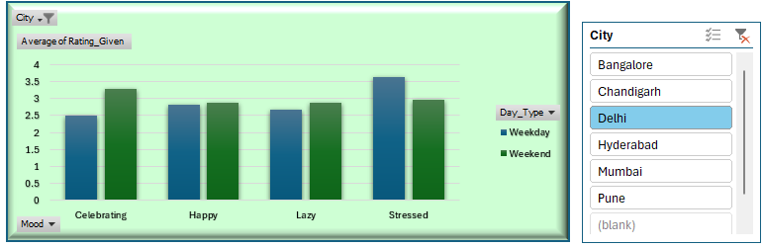
- Clustered column chart — Average Order Value by Restaurant Tier
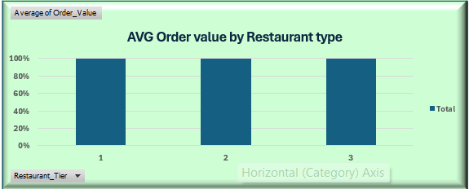
- Column chart — Average Rating by Mood
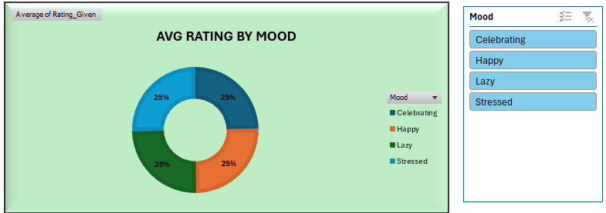
- Column chart — Repeat Orders by City
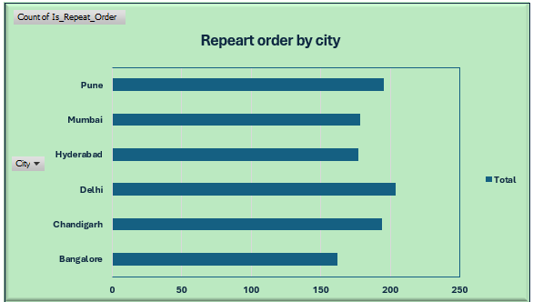
- Column chart — Average Delivery Time by Rainy Weather
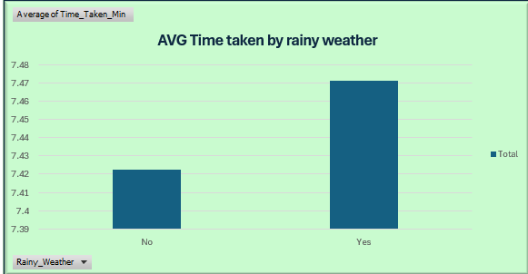

4. Part B — Power BI Dashboard

4.1 Data Import & Modelling
The cleaned dataset was imported into Power BI Desktop as a single flat table (food_ordering_behavior). Given the dataset size and structure, no additional relationships were required; all analysis was performed using DAX measures over the single table.

4.2 DAX Measures Used
Measure | DAX Expression | Result
Total Orders | COUNTROWS(food_ordering_behavior) | 1,110
Total Revenue | SUM(food_ordering_behavior[Total_Charge]) | Rs. 6,71,326
Avg Order Value | AVERAGE(food_ordering_behavior[Order_Value]) | Rs. 544.71
Avg Rating | AVERAGE(food_ordering_behavior[Rating_Given]) | 3.00
Avg Delivery Time (min) | AVERAGE(food_ordering_behavior[Time_Taken_Min]) | 7.45
Repeat Orders | CALCULATE(COUNTROWS(...), Is_Repeat_Order = “Yes”) | 528
Repeat Order Rate | DIVIDE([Repeat Orders], [Total Orders], 0) | 47.6%
Average of Discount_Flag | AVERAGE(food_ordering_behavior[Discount_Flag]) | 48.0%

4.3 Dashboard : Overview
Presents the full-dataset overview: a hero banner, four KPI slicers, five summary cards, and four supporting charts.
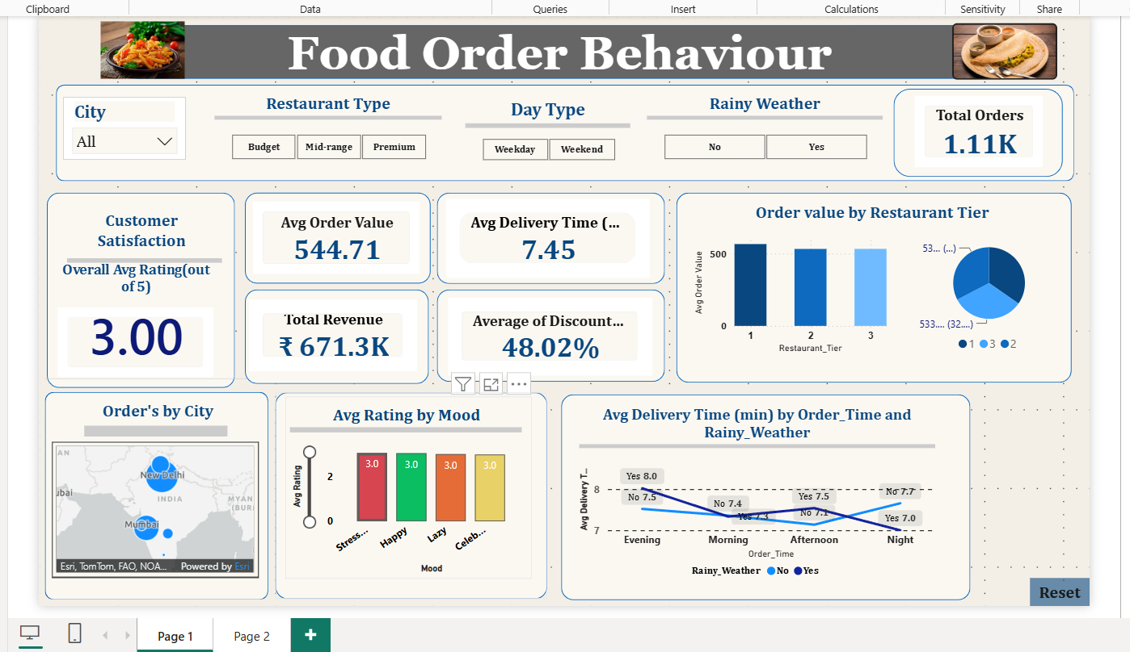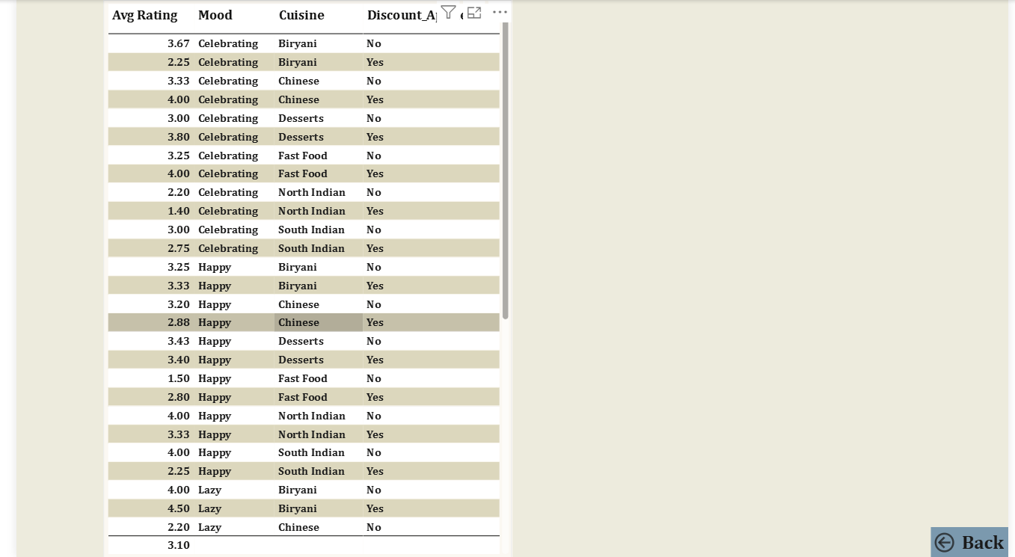

4.4 Interactive Features
Feature | Purpose
Slicers (City, Restaurant Type, Day Type, Rainy Weather) | Allow the viewer to filter every visual on the page simultaneously
Cross-filtering | Clicking any chart element filters all other visuals on the page automatically
Reset button | Restores the default, unfiltered view via a saved bookmark
Page navigation | Moves between Page 1 (Overview) and Page 2
Map bubble sizing | Bubble size on the city map scales with order volume, giving an at-a-glance geographic comparison

5. Key Insights
- 47.6% of all orders are repeat orders (528 of 1,110)
- Restaurant Tier 1 has the highest average order value (Rs. 566.8) compared to Tier 2 and Tier 3, which are nearly identical (Rs. 533).
- Customer mood has minimal effect on rating
- Rainy weather has almost no effect on overall delivery time ,though the effect varies by time of day — rainy evenings are the slowest while rainy nights are the fastest .
- Delhi has the highest order volume (204 orders) among the six cities, followed closely by Pune (195) and Chandigarh (194).

6. Conclusion
This project demonstrates an end-to-end data analysis workflow — from raw data cleaning and validation in Excel, through PivotTable-based exploratory analysis, to a fully interactive Power BI dashboard with slicers, a geographic map, KPI cards, and page navigation. Particular attention was paid to data accuracy, including identifying and correcting a repeat-order counting error that appeared in both the Excel PivotTable and, initially, an early draft of the Power BI measure. The final dashboard presents a clear, interactive, and visually consistent summary of food ordering behaviour across six Indian cities.

Appendix A: Full DAX Measure Reference
Total Orders = COUNTROWS(food_ordering_behavior)
Total Revenue = SUM(food_ordering_behavior[Total_Charge])
Avg Order Value = AVERAGE(food_ordering_behavior[Order_Value])
Avg Rating = AVERAGE(food_ordering_behavior[Rating_Given])
Avg Delivery Time (min) = AVERAGE(food_ordering_behavior[Time_Taken_Min])
Repeat Orders = CALCULATE(COUNTROWS(food_ordering_behavior), food_ordering_behavior[Is_Repeat_Order] = "Yes")

Appendix B: Dataset Column

Order_id, User_id, Age, Age_Group, City, Order_Time, Day_Type, Cuisine, Meal_Type, Restaurant_Type, Restaurant_Tier, Order_Value, Discount_Applied, Discount_Flag, Delivery_Fee, Total_Charge, Time_Taken_Min, Rating_Given, Is_Repeat_Order, Mood, Hunger_Level, Company, Rainy_Weather
Data Source
https://www.kaggle.com/datasets/rhythmghai/food-ordering-behavior-india-50k-orders

